Thaipusam Festival

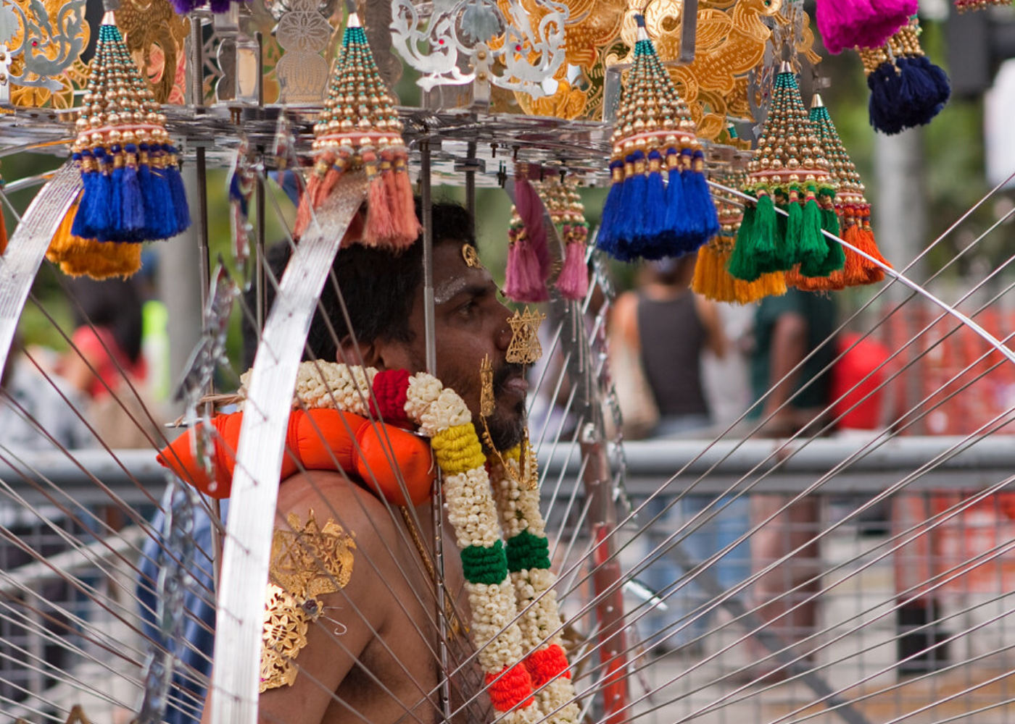

Majority of the devotees who participate in Thaipusam are Hindu Tamils, but it’s not uncommon to find Hindus of other ethnicities taking part in the procession. This is especially true in Singapore, considering our vibrant mix of cultures.

Celebrated in early February on the brightest moon night,

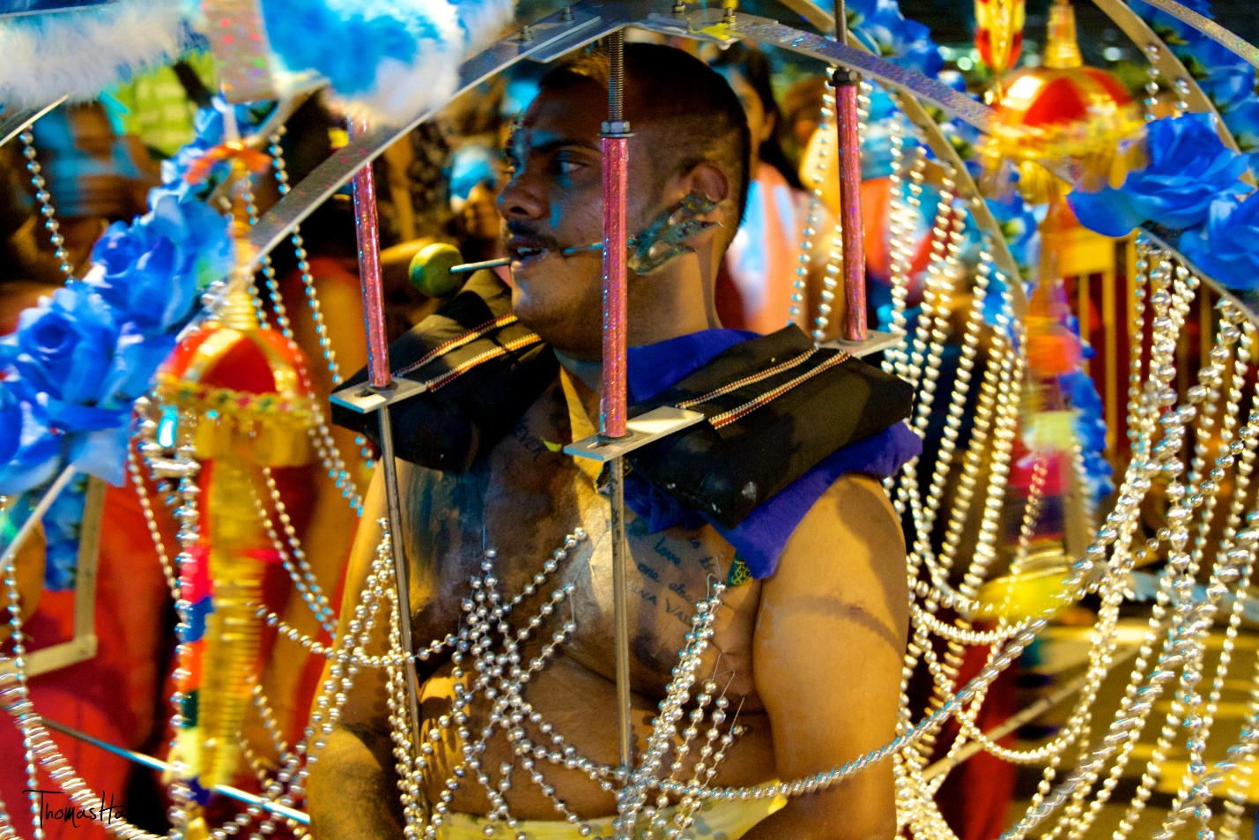

Okay! Statutory warning first – the processions during this festival is not for the light-hearted. Sharp skewers pierced through tongues, cheeks and bodies as a practice of self-mortification, the devotees may send shivers down an onlooker’s spine.

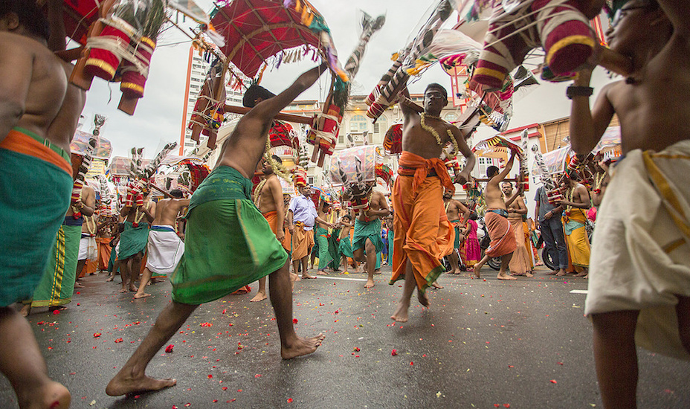

The most iconic part of this festival is the kavadi itself. This intricate structure is decorated with flowers and peacock feathers (symbols of Murugan), and it can weigh up to 30 kilos and reach up to four metres. While this may seem like a harrowing experience, kavadi bearers often feel a sense of peace and may even enter a trance-like state. This is aided by live music played by urumi melam (traditional drum) groups.

Thaipusam is a thanksgiving of sorts for devotees to celebrate the fulfilment of their vows and show their gratitude towards Lord Murugan for granting them favours. A month is spent to spiritually prepare for the big day, with worshippers upholding a strict vegetarian diet.

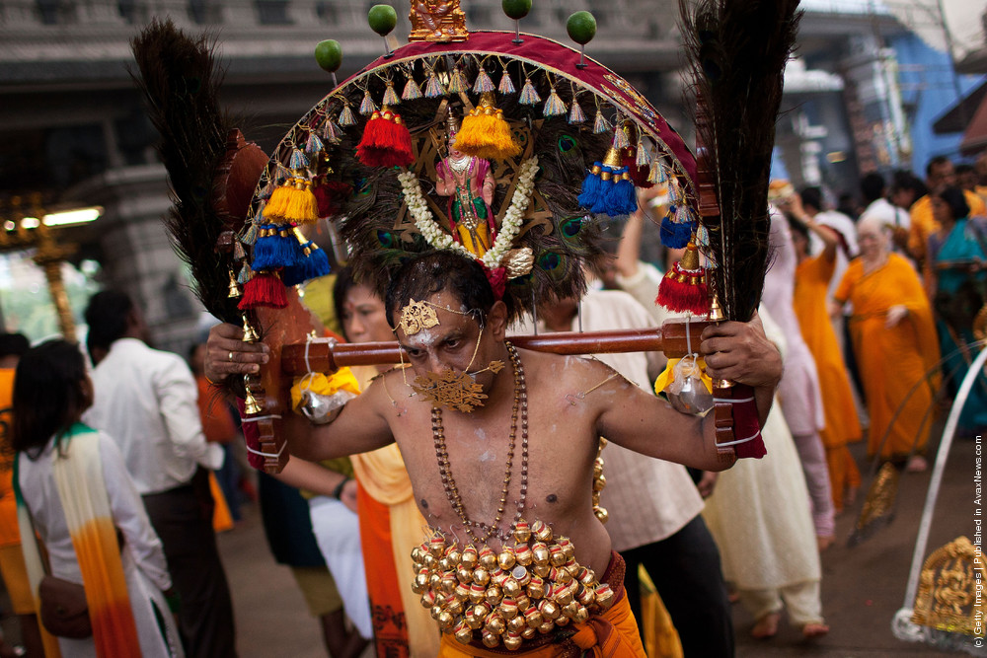

The procession of kavadi bearers begins at the Sri Srinivasa Perumal Temple at Serangoon Road and ends at the Sri Thendayuthapani Temple at Tank Road. If you’re keen to see the spectacle firsthand, then Serangoon Road is a good place to catch the procession. The entire route measures 4.5 km.

**Don’t miss:**The final stage of the procession, sweets that are distributed after being served as an offering to God  
**When:**8th February 2020